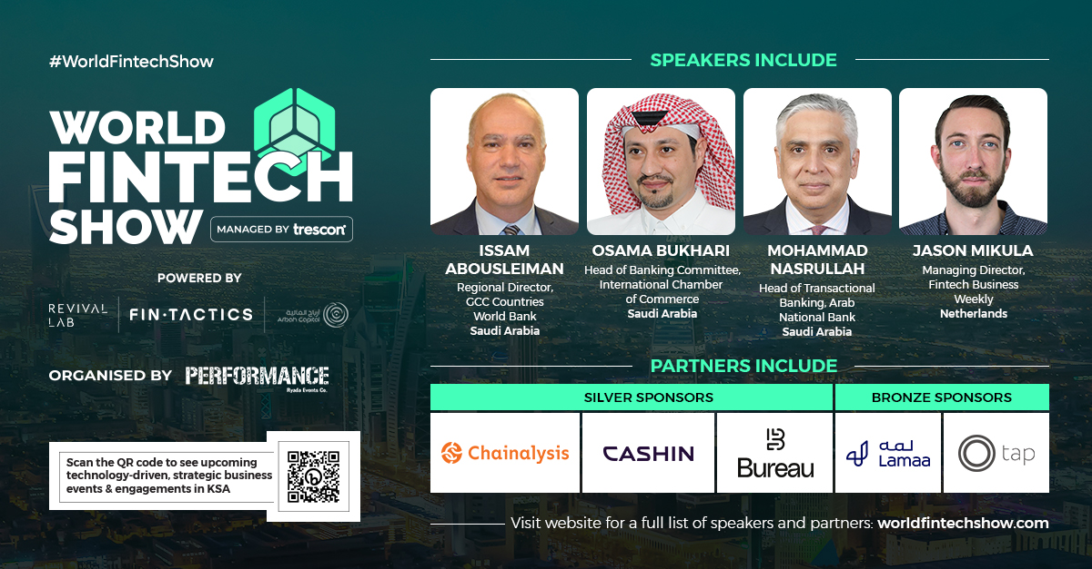

Trescon’s World Fintech Show set to re-invent fintech by bringing together global innovators in KSA
Powered by Revival Lab, Fintactics, and Arbah Capital, Trescon's World Fintech Show, one of the most-elite fintech events in the world will be hosted in Riyadh, Saudi Arabia on the 5th and 6th of December 2022, at InterContinental Riyadh. A collaboration of businesses, investors, policymakers, government officials, and partners will re-imagine comprehensive financial services by adopting the most impactful technologies.
Friday, December 2, 2022: Saudi Arabia is undergoing massive economic development transformations keeping fintech as a pivotal strategic pillar. Upholding this pragmatic vision is the World Fintech Show, scheduled to take place at InterContinental Riyadh on the 5th and 6th December 2022. The event’s prime focus will be on unleashing the thriving fintech ecosystem in Saudi Arabia.
The 2-day initiative is prepared to traverse the future of fintech in Saudi Arabia, as well as examine the effects of revolutionary and transformative measures undertaken to restructure digital and decentralized finance.
The initiative will bring together industry-leading C-level executives, investors, directors, and leaders from finance, banking, retail, telecom, blockchain, and AdTech.
“World Fintech Show is one of the few summits you should attend to get an insightful view of this ever-fast-growing industry," says Ahmed Elsayed, Head of Digital Delivery, Bank Albilad, Saudi Arabia.
As urbanization expands, one of the most in-demand sectors in Saudi Arabia is fintech. The event will provide an extensive analysis of the Saudi Arabian fintech market, which includes a review of the economy, an estimation of the market's size for major segments, developing market trends, and market dynamics.
Head of Digital Architecture & Infrastructure at Banque Saudi Fransi, Rateesh Upendran, comments on the anticipated fintech growth in Saudi Arabia. Rateesh says, “The Saudi Arabian banking and financial services industry is at the crossroads of a massive transformation. The emerging fintech innovators will challenge incumbents with digital innovation as their strategic priority. I am looking forward to meeting and connecting with the innovators and thought leaders of the world fintech industry.”
The World Fintech Show will present several notable industry speakers, such as:
- Issam Abousleiman, Regional Director, GCC Countries World Bank
- Osama Bukhari, Head of Banking Committee, International Chamber of Commerce
- Nabil Issa, Managing Partner, King & Spalding LLP
- Dr. Bijna Kotak Dasani MBE, FRSA, CEO & Founder Bijna.com
- Jason Mikula, Managing Director, Fintech Business Weekly
- Dr.Yahia Kafi, Head of Financial Planning & Analysis, Abdul Latif Jameel
- Nameer Khan, Chairman, MENA Fintech Association
- Alexia Hefti, Executive Chairman, Abed Ventures
- Abe Karkar, Cheif Product Officer, Fintech Galaxy
- Mohammad Nasrullah, Head of Transactional Banking, Arbab National Bank
- Hashim Nabulsi, Director, NEOM
- Sam Kateila, Chairman of the Board, Crypto Valley Partners
- Sultan Al Halmidi, Chief Business Officer, Social Development Bank
- Rateesh Upendran, Head of Digital Architecture & Infrastructure, Banque Saudi Fransi
- Majed Alanazi, Head of Trade Finance, Alinma Bank
- Karl Tlais, Founder, Strategic Advisor, iAdvisory
- Ivo Detelinov, Partner, Hambro Perks Oryx Fund
- Hussein Attar, CEO, Tech Invest Com
- Basmah Alsinaidi, Partner, Impact46
- Faisal Alrashoudi, Head of Automation & Robotics, Bank Al-Jazira
- Joosep Vahtras, Compliance Advisory Lead, Chainalysis Inc.
- DR. Ahmed Elsayed, Head of Digital Delivery, Bank Albilad
- Rayan Al-Karawi, Chairman, Razeen Capital
- Anjum Mirza, Head Trade Finance, Saudi National Bank
- Mehdi Fichtali, Chief Executive Officer, Finamaze
- Emon Shakoor, Founder & CEO, Blossom Accelerator
- Wasif Hasan, Senior Director Global Tade & Supply Chain, Al Rahji Bank
- Faisal Alshibil, Director, UBS Saudi Arabia
- Preekshit Gupta, Regional Vice President & MEA, Bureau Inc
- Nasreen Al Issa, Founder Fintech Buddy Saudi Arabia, Founder The Law Firm of Nasreen Al Issa
When examining the forthcoming developments in the financial industry, World Fintech Show will talk about digital transformation in its entirety. Insightful discussions will explore the limitless opportunities for all businesses to be a fintech company, catalyzing for the Saudi Vision 2030.
Partner at Impact46, Basmah Alsinaidi, comments on the World Fintech Show, “World Fintech Show is a great opportunity to showcase the development of the fintech scene and create synergies across the field.”
Mithun Shetty, CEO of Trescon said, “Saudi Arabia has a very clear goal for itself, and it intends to be the epicenter for the application of fintech services. We intend to showcase to the world through the World Fintech Show the multifaceted approach that will lead the Kingdom's fintech ecosystem to the top.”
Leading global corporations from 10 different countries are supporting World Fintech Show. The event is officially Powered by Revival Lab, Fintactics, and Arbah Capital, and a list of distinguished sponsors, each one backed by a history of excellence are collaborating to establish a platform for the future. These include:
- Association Partners: Fintech Business Weekly | MENA Association
- Silver Partner: Chainalysis | Bureau | Cashin
- Bronze Partner: Lamaa | Tap
- Digital Partner: Eye of Riyadh
- Official Event App Partner: CrowdComms
- Official Media Partner: The Fintech Times
- Exhibitors: Stay Connected | Al Jabr | Chainup | Expand my business | Finaid | Sapid Blue | Abdulmohsen Alhomaid Law Firm | Airpay
- Startup Exhibitor: Accurascan | Podyam | Kilde | OFF-CHAIN YIELD | NowPay | SDLC Corp
For more information, visit: World Fintech Show - Saudi Arabia
About The World Fintech Show
World Fintech Show is a thought-leadership-driven, business-focused event that deep dives into the latest challenges and technology trends in Saudi Arabia's financial services sector.
World Fintech Show sets the standard for financial innovation in the Kingdom by connecting global fintech experts, technology innovators and startups with pre-qualified CFOs, CEOs, CTOs, Heads of Business Transformation, Chief Digital Officers, Heads of Innovation, government authorities, and fintech investors from Saudi Arabia.
The event features exciting keynotes, enterprise use-case presentations, product showcase, panel discussions and tech talks. Witness next-gen fintech solutions from global tech leaders and explore their relevance and impact on organizations.
About Trescon
Trescon is a global business events and consulting firm that provides a wide range of business services to a diversified client base that includes corporations, governments, and individuals. Trescon specializes in producing highly focused B2B events that connect businesses with opportunities through conferences, roadshows, expos, demand generation, investor connect, and consulting services.
For further details about the announcement, please contact:
Nupur Aswani
Head – Media, PR and Corporate Communications, Trescon
+91 9555915156 | media@tresconglobal.com

